Euler Requirements Specification

Jose Ramirez, Mala Pahari, Landon Frederes, Kurtis Waldner

Table of Contents

Business Requirements 2

What is the purpose? 2

What is already in place? 2

What should it do? 2

Monetization or business model? 2

Branding and design guidelines? 2

Is it feasible? 2

User Requirements 3

User Steps Through the App 3

Overview of User Steps Through the App 3

Functional Requirements 4

Nonfunctional Requirements 5

Implementation Requirements 6

Common Requirements 7

Screens 7

Alerts (Small centered screens that prompt for user input) 7

Menus 7

Navigation 7

Work Flow 7

Login, Audit, Archiving 7

Configuration 7

User Type 8

Use Cases 9

User Stories 10

# Business Requirements

### What is the purpose?

The purpose of the app is to help people improve their mental capability for arithmetic calculations and quick solving skills. It can also allow them to improve thinking if placed under a stressful situation, such as adding a timer for each game (post MVP at the moment; user story is not in current scope).

### What is already in place?

There are several apps already for mental math but none of them seem to be the same gameplay as this one.

### What should it do?

It should display a 4x4 board with symbols and row and column totals. It allows the player to select a symbol and assign it a numeric value. Once the whole board is complete, the player can submit the game or choose other options such as restarting or clearing the board.

### Monetization or business model?

The app is free but if there’s a large number of downloads, then the app will cost $0.99 if given enough positive reviews.

### Branding and design guidelines?

UI/UX document that the UI/UX designer will create as part of user stories. Currently, there is no specific color/style for the app.

### Is it feasible?

Yes, because only required one language and program to create the app. Low overhead.

# User Requirements

The user interface will be user driven; meaning that there will not be dialogs or menus guiding the user through the application. Gameplay and menus will be triggered by user actions, not automatic. User actions are defined by tap gestures on the touch screen device.

No information from the user will be required and no user sensitive data will be saved into the app.

### User Steps Through the App

* The user downloads the app for free on their iOS device.
* The user will open the app and be presented with the home screen.
* The user can read the different difficulties in the home screen.
* The user will select a difficulty button and proceed to the new game screen.
* The user will have to solve the puzzle by assigning numbers to symbols in the table.
* While playing the game, the user is not tied down to a specific flow; they have freedom.
* The user can choose from several menu buttons: submit game, clear game, or new game.
* Only a single instance of the game can be in progress.

### Overview of User Steps Through the App

User will select a game difficulty, play the game, and chose to start a new game with a different difficulty.

# Functional Requirements

* The program launches when the user selects the application.
* The program shows the instructions when prompted.
* The program changes set difficulty when prompted.
* The program begins the game when prompted.
* The program launches the new game when prompted.
* The program creates a grid.
* The program fills the grid with symbols.
* The program assigns the symbols with values.
* The program creates totals around the grid.
* The program has a submit button.
* The program starts a timer once the game loads.
* The program can validate the board for correctness when the submit button is used.
* The program will end the game if the user is correct.
* The program will allow the user to try again if the submission is incorrect.
* The program will allow the user to clear changes to the board at any time.
* The program will return to pre-game state if the user wins.
* The program will return to pre-game state if the user quits the game in progress.

# Nonfunctional Requirements

* The game loads within 5 seconds.
* The new game loads within 1 seconds.
* The user can turn the sound off or on.
* The unique symbols never have the same value.
* The totals on the grid always equal the sum of the adjacent column or specific diagonal values.
* The program saves the score of the user.
* The game must work on the current iOS.
* If the program crashes, an email is sent to the developer from iTunes Connect.
* A popup to review the game will appear (low chance) after submitting a game.

# Implementation Requirements

Will not replace any existing application in place and will not require users to buy any hardware.

Create a user guide which will include the information about the rules, how to play and different difficulties of the game.

Hire a social media intern to introduce our application to the users through various social media platforms.

Arrange a user meetup where users with different devices will use the application to understand how the app will perform in different devices.

# Common Requirements

### Screens

Splash Screen: Displays screen with the logo of the game briefly.

Title Screen: Displays different difficulties of the game and their information.

Game Screen: Displays the game after user makes the selection (Easy, Medium, Hard).

### Alerts (Small centered screens that prompt for user input)

New game alert: when the user taps the new game button.

Submit alert: when the user taps the submit button.

Clear board alert: when the user taps the clear board button.

Go back to title screen alert: when the user taps the menu button.

### Menus

The menu options will already be on the screen; the user does not need to tap any button to present the menus.

Title Screen: Contains 3 difficulty options/buttons and their information.

Game Screen: new game, submit game, clear board, clear symbol, and menu button.

### Navigation

The user will navigate through button taps which will direct them to certain screen. There will also not be a navigation bar on top that allows them to navigate through the app like default iOS applications. There is also no swiping-left-to-go-back gesture.

When user taps a difficulty button in the title screen, they will go to the game screen.

To go back to the title screen, the user taps the home button in the game screen.

### Work Flow

Data will be saved in a shared location that can be accessible anywhere in the application such as what difficulty was selected.

### Login, Audit, Archiving

No user accounts are required for the app so there is no login or sign up. There is also no audit or archiving.

### Configuration

The application will let the user turn sounds on or off and choose the game difficulty. No other configuration.

### User Type

There will be only one type of user who will use the application (play the game) so there are no privileges required.

# Use Cases

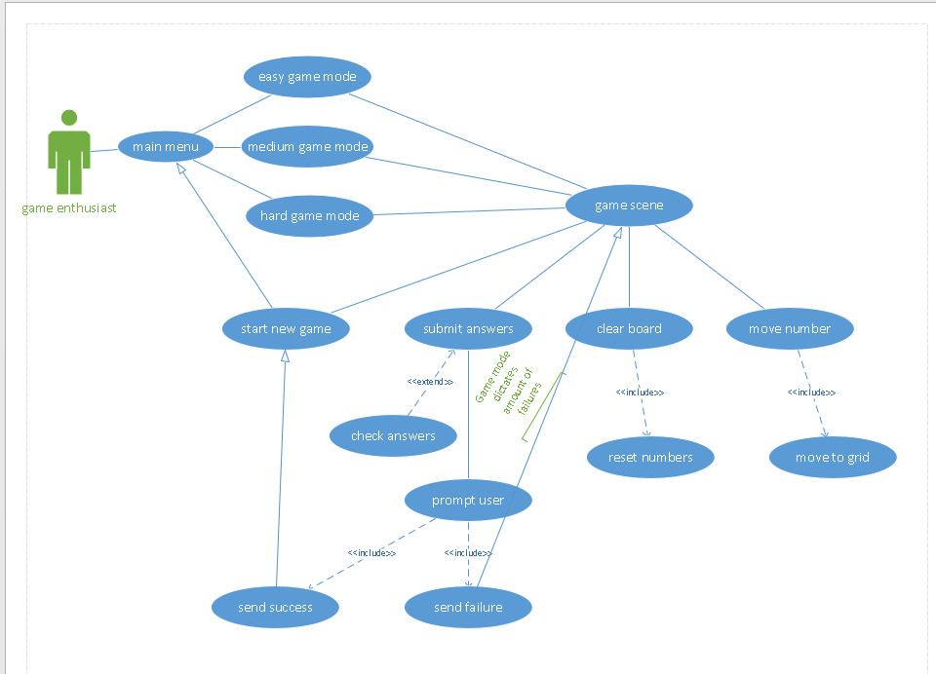

# User Stories

|  |  |  |  |
| --- | --- | --- | --- |
| Epic | Story Title | Description | QA Acceptance Criteria |
| UI/UX | Design the Main Menu Scene/Environment | As a project manager, I want to have a main menu with a description and buttons of each difficulty so that players can know what kind of game they are about to start. | No QA |
| UI/UX | Create Design Layout | As a UI/UX designer, I want to have a basic scratch design of the layout to make the actual design easier so that I may save time. | No QA |
| UI/UX | Create a UI/UX Document | As a UI/UX designer, I want to have a document that can make it easier to translate UI/UX requirements to developers to save time and for documentation purposes. | No QA |
| UI/UX | Design the Grid Background | As a UI/UX designer, I want to have design for the grid so that users can easily distinguish rows and columns for easier gameplay. | No QA |
| UI/UX | Design the Background for Menu Buttons | As a UI/UX designer, I want to have a background for the buttons so that the user knows they can tap them. | No QA |
| UI/UX | Design the Background for Number Buttons | As a UI/UX designer, I want to have a background design for the number buttons so that the user knows they can tap them. | No QA |
| UI/UX | Design the Home and Sound Button | As a UI/UX designer, I want to have a background design for the home button and sound button so that the user knows they can tap them. | No QA |
| UI/UX | Design the Game Screen Background | As a UI/UX designer, I want to have a background for the game so that the user feels engaged in the game and not bored or distracted. | No QA |
| UI/UX | Design the Popup for the Clear Button | As a UI/UX designer, I want to have a design for the popup that appears when the user taps the clear button, so they know that they need to respond to it before continuing the game. | No QA |
| UI/UX | Design the Popup for the Submit Button | As a UI/UX designer, I want to have a design for the popup that appears when the user taps the submit button, so they know that they need to respond to it before continuing the game. | No QA |
| UI/UX | Design the popup for the New Game Button | As a UI/UX designer, I want to have a design for the popup that appears when the user taps the submit button, so they know that they need to respond to it before continuing the game. | No QA |
| UI/UX | Design the Game Scene/Environment (Hard) | As a UI/UX designer, I want to have a design/layout if the game is in hard mode to make it easier for developers to display the correct game format. | No QA |
| UI/UX | Design the Game Scene/Environment (Medium) | As a UI/UX designer, I want to have a design/layout if the game is in medium mode to make it easier for developers to display the correct game format. | No QA |
| UI/UX | Design the Game Scene/Environment (Easy) | As a UI/UX designer, I want to have a design/layout if the game is in easy mode to make it easier for developers to display the correct game format. | No QA |
| Develop | Develop the Transition Between the Main Menu and Game Screen | As a project manager, I want a transition to occur when the user selects any of the difficulty buttons to go to the game screen and present the game screen dependent on the difficulty chosen. | Pressing any difficulty button on the main screen should transition to a new game. Test all 3 difficulties. |
| Develop | Develop the Main Menu Screen | As a project manager, I want the game to fit the device size accordingly so that users with various device sizes can play the same equally. | Test the game on iPhone SE, regular and plus model, X, Xr, and Xs Max. |
| Develop | Add Sound when Tapping Button or Selection | As a project manager, I want a sound to play when the user has selected a symbol or pressed any button. | Test a sound plays when pressing any button or selecting a symbol. |
| Develop | Develop the Submit Button Logic | As a user, I want to be able to submit the game I completed so that I can move on to a new game and make sure all my answers were correct. | Complete a game and make sure submit button works to start a new game. |
| Develop | Develop the Clear Symbol Logic | As a user, I want to be able to clear a symbol from a number I previously assigned it so that I can reset the use of the number and see the symbol that was in the grid. | Select a symbol and assign it a number; then press the clear symbol button. Symbol should reset and remove number. |
| Develop | Develop the New Game Button Logic | As a user, I want to be able to start a new game with new symbols and totals so that I can start a new game. | Tap new game button and make sure new game occurred. |
| Develop | Develop the Clear Button Logic | As a user, I want to be able to clear the entire grid of all the numbers I assigned to symbols so that I can have a fresh start of the current game. | Assign numbers to all symbols. Push clear button. Grid should remove all numbers. |
| Develop | Develop the Button Numbers Logic for Selection | As a user, I want to be able to select a symbol and then assign a number to it so that I can complete the game. | Select a symbol. Select a number. Symbol should change to that number. |
| Develop | Develop the Grid Logic for New Games | As a project manager, I want the grid to randomly assign values to symbols and then present the symbols and row and column totals in the grid depending on the difficulty so that users can play the game. | Tap new game. I want the symbols and column and row totals to be new. |
| Develop | Develop the Game Screen | As a developer, I want the storyboard for the game screen to have all corresponding outlets to avoid conflicts with other developers if working on the same storyboard. | No QA |
| Develop | Add the Review Alert | As a project manager, I want the default iOS review alert to show up when the user submits a game so that we can get reviews for the game. | Play several games and tap the submit button. The review alert should display by a low chance. |
| Develop | Add a Home Button | As a project manager, I want a home button to display on the game screen so that I can go back to the title screen. | Press the home button in the game screen. Go back to title screen. |
| Develop | Add a Sound Button | As a project manager, I want a sound button in the title screen so that users can choose to mute sound effects or not. | Press the sound button. Press any button. Make sure no sound plays. Press sound button again. Make sure sound plays. |
| Develop | Add an Instructions Button | As a project manager, I want to an instructions button to display on the title screen so that I can know how to play the game. | Press the instructions button. An image displays of how to play. |
| Develop | Create the Initial Xcode Project and Bitbucket Repository with Onboarding Guide | As a developer, I want the initial Xcode project to be committed to a Bitbucket repository to make it easier for any developer to work on it so that development may begin. | No QA |
| App Store | Prepare App for App Store Submission | As a project manager, I want the app to be prepared to be able to be submitted to the App Store without any issues. This includes making sure all corresponding fields for the app are good for submission. | No QA |
| App Store | Generate App Store Screenshots | As a user, I want to see engaging and interesting app screenshots, so I may be interested and tempted to download the app if I were to see it in the App Store. | No QA |